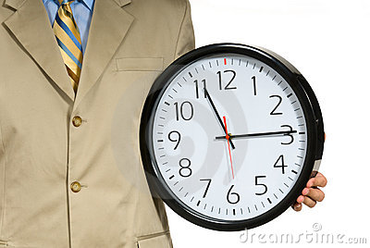
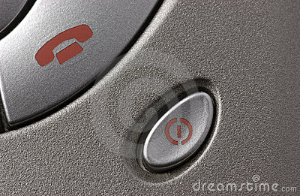

OUR HOUSE RULES for being a team player





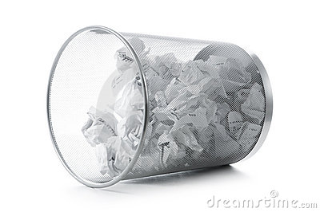
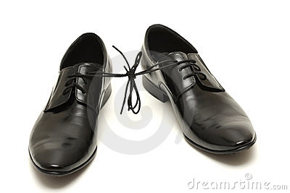
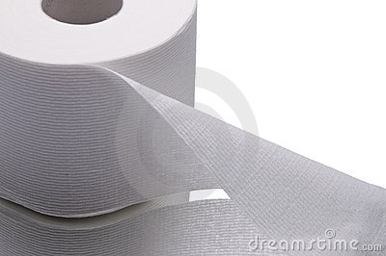
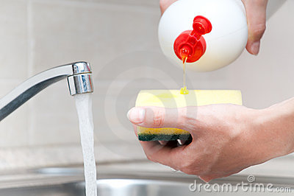
Signed: Date: / /

I understand and agree to abide by the rules above…
Smoke Only
In designated places

Check Twice
Be thorough

Dress for Success
Uniform & Nametag

Tidy Up
Don’t leave a mess

Be Clean
Shave, wash & don’t Smell

Use internet wisely
No porn or social stuff

No PRANKS
Avoid Death and Danger

Replace the paper
Toilet, Fax & Copier

Clean up after yourself
Your mum doesn’t work here

Switch off your mobile
Private calls in your own time

ne
Toilet, Fax and copier

Sick Notification by phone - Not SMS

ne
Toilet, Fax and copier

Be on time for work
We start at ____

